**IR Module Description Document**

**1.Introduction to the IR Module**

**1.1 Introduction**

The AP80 series chip has a built-in hardware infrared decoder that only supports the NEC protocol (please refer to the relevant standard definitions for the protocol). An external infrared receiver is required to use the infrared decoder. The IR reception channel can be multiplexed with one of the following GPIOs:

* GPIO_A10
* GPIO_B7
* GPIO_C2

Transmission code representation under NEC standards:

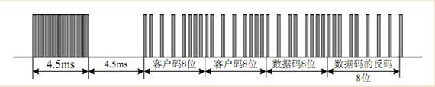

Figure 1 NEC Transmission Coding Diagram

Translation:

客户码8位= 8-digit customer code

客户码8位= 8-digit customer code

数据码8位=8-digit data code

数据码的反码=Complement code of the data code

8位=8-digit

**1.2. Function Introduction**

According to the NEC protocol specifications, user key presses can be categorized into short presses and long presses. A short press occurs when an IR signal is received but no further key press signals are detected. For a long press, if the key is held down for more than 108 milliseconds without being released, the transmitter will send a continuous signal consisting solely of start and stop codes. At the AP80 end, the number of start codes detected indicates that the key is in a long-press state.

1. **Typical Cases**
   1. **Short Key Press**

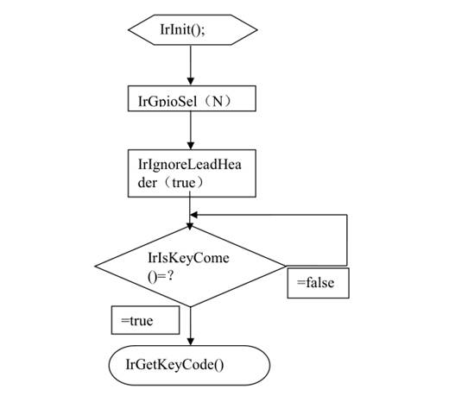

Figure 2 Short Key Press Operation Diagram

**2.2. Long Key Press**

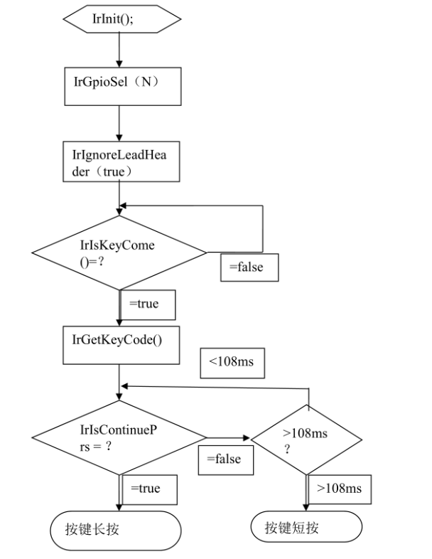

Figure 3 Long Key Press Operation Diagram

Translation:

按键长按=Long press the button

按键短按=Short press the button